**LAPORAN HASIL PENGERJAAN**

**JOBSHEET 1 PEMROGRAMAN BERBASIS FRAMEWORK**



**Oleh :**

**Dwityantherrys Bekti Utomo**

**1941720033**

**MATA KULIAH BUSINESS INTELLIGENCE**

**PROGRAM STUDI TEKNIK INFORMATIKA**

**JURUSAN TEKNOLOGI INFORMASI**

**POLITEKNIK NEGERI MALANG**

**2021/2022**

1. **Const**

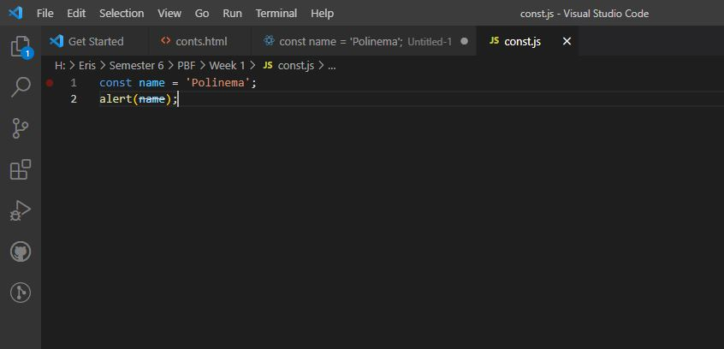

Gambar 1 SC const.js

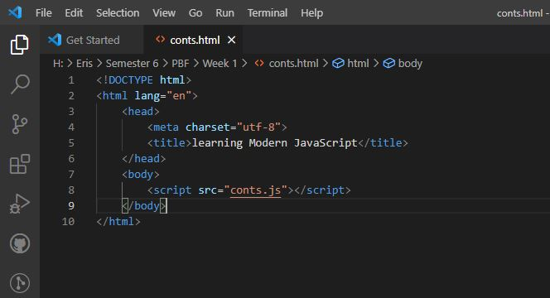

Gambar 2 SC const.html

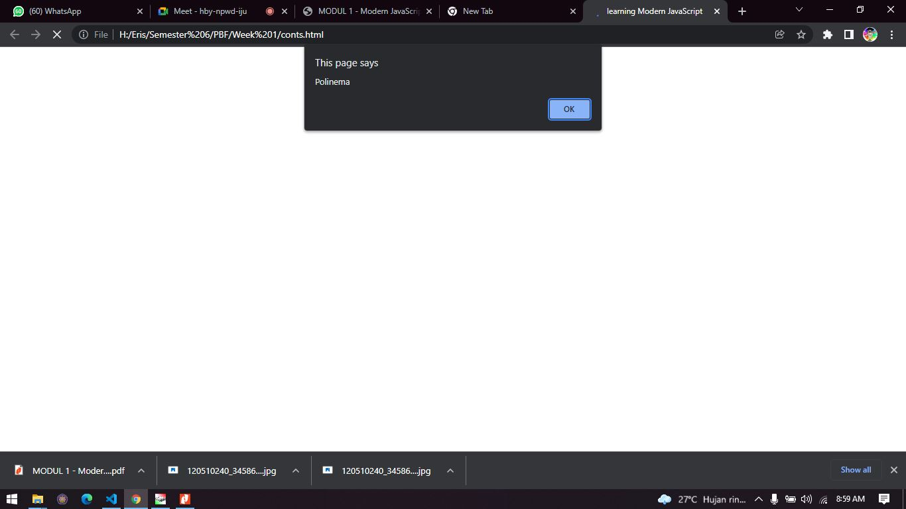

Gambar 3 Hasil

1. **Let**

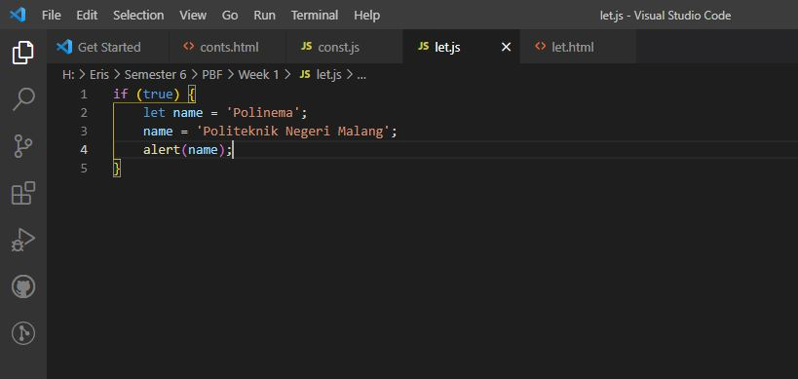

Gambar 4 SC let.js

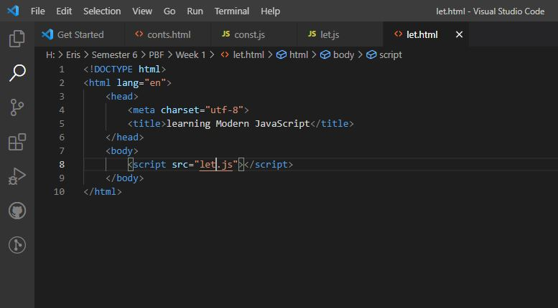

Gambar 5 SC let.html

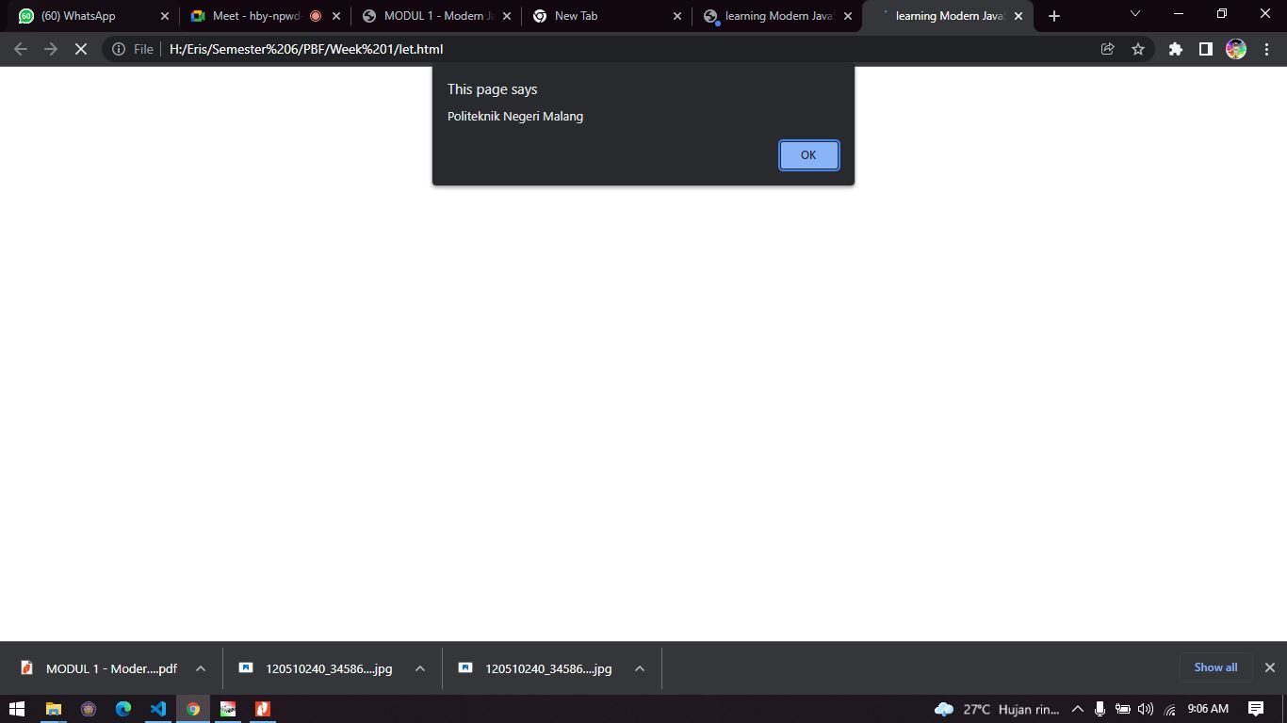

Gambar 6 Hasil

1. **String**

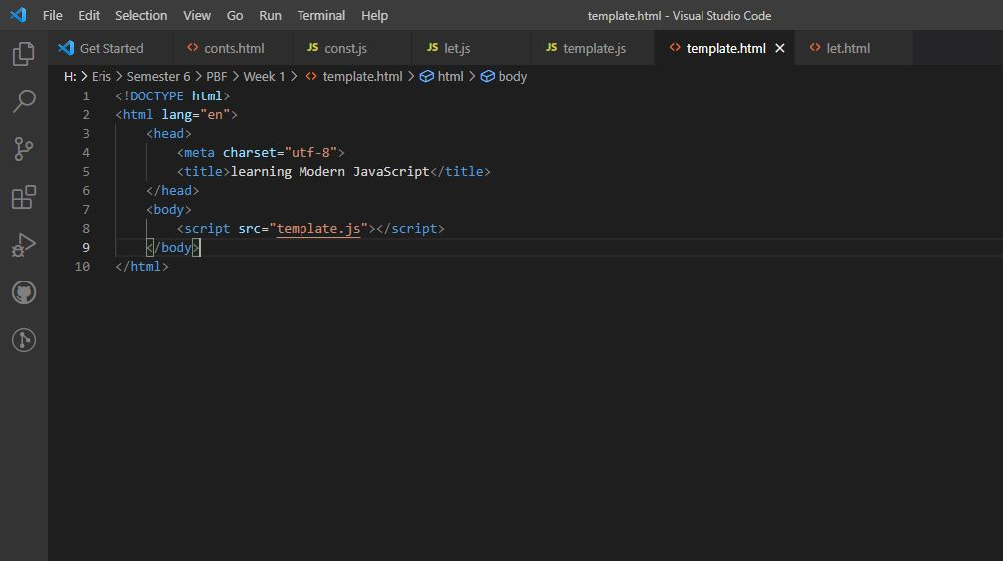

Gambar 7 SC template.html

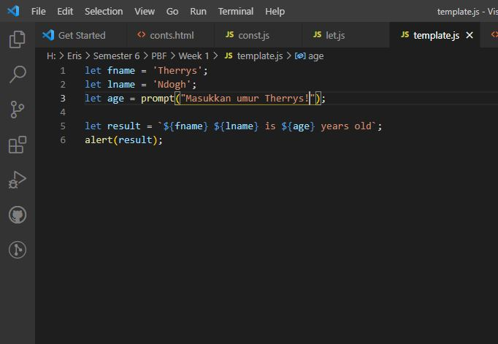

Gambar 8 SC template.js

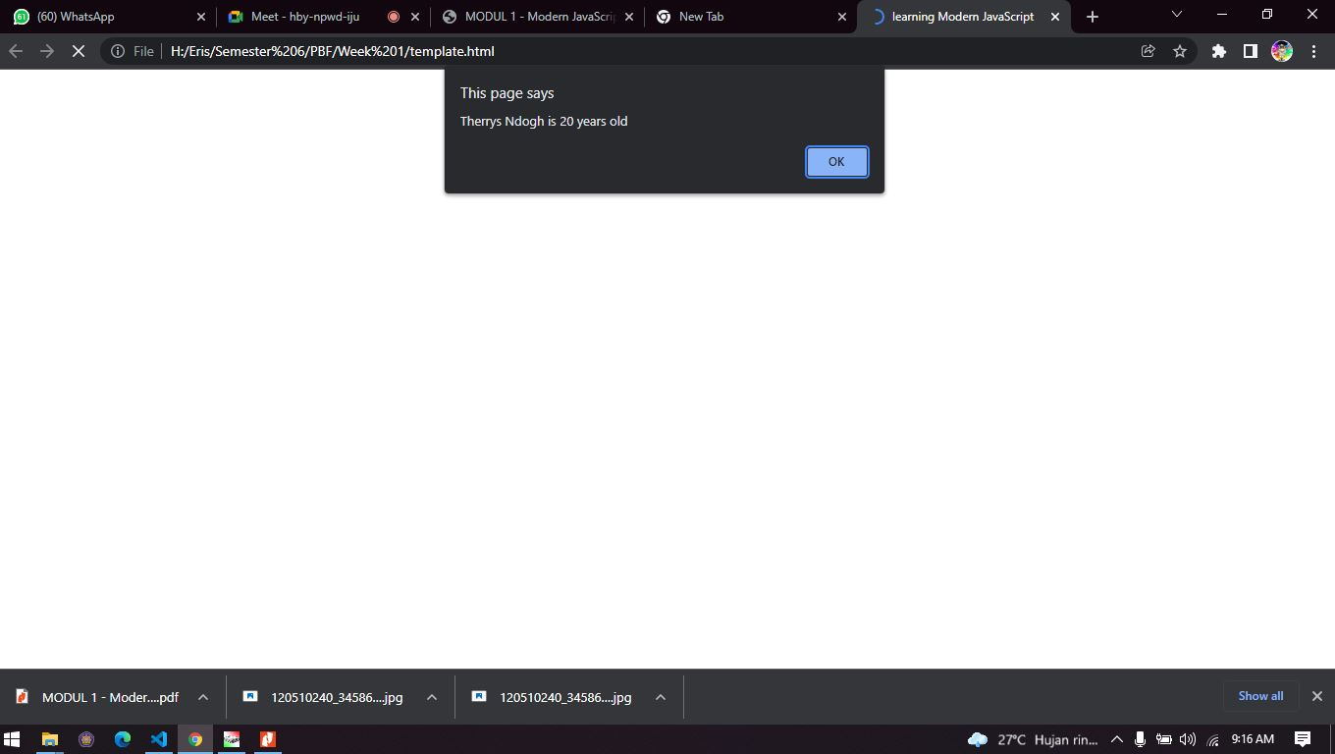

Gambar 9 Hasil

1. **Default Parameters**

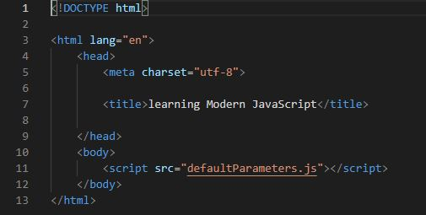

Gambar 10 SC defaultParameters.html

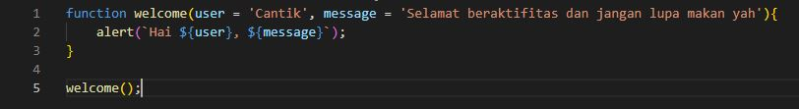

Gambar 11 SC defaultParameters.js

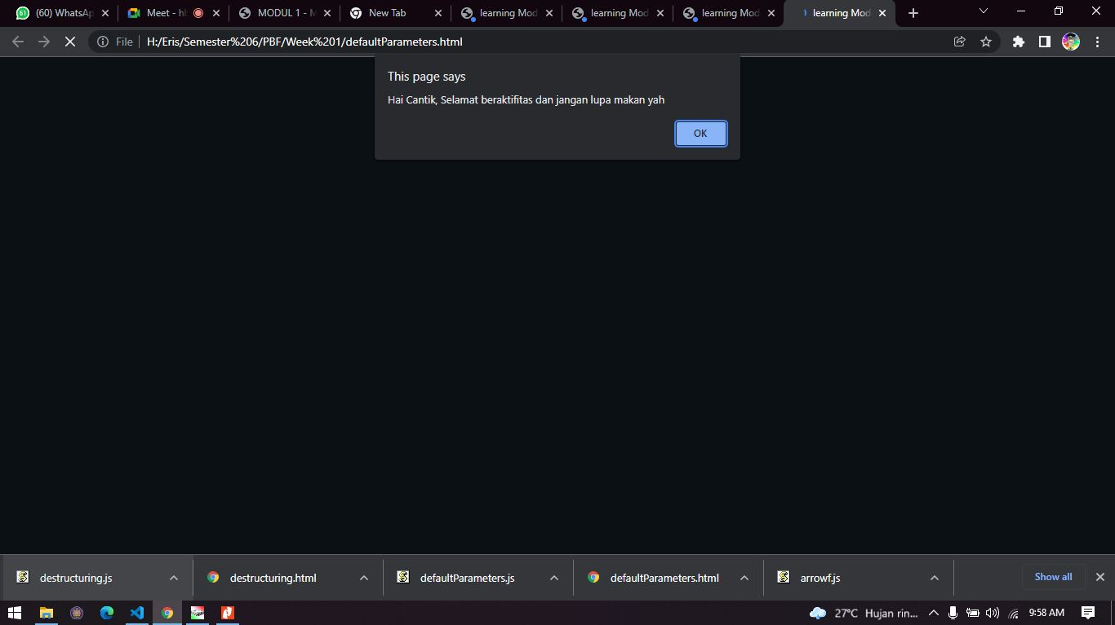

Gambar 12 Hasil

1. **Arrow Function 1**

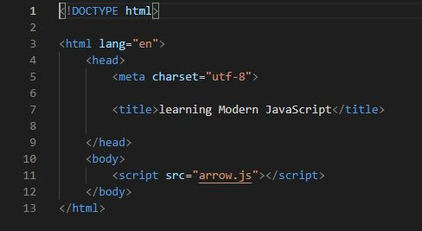

Gambar 13 SC arrow.html

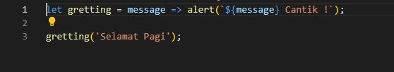

Gambar 14 SC arrow.js

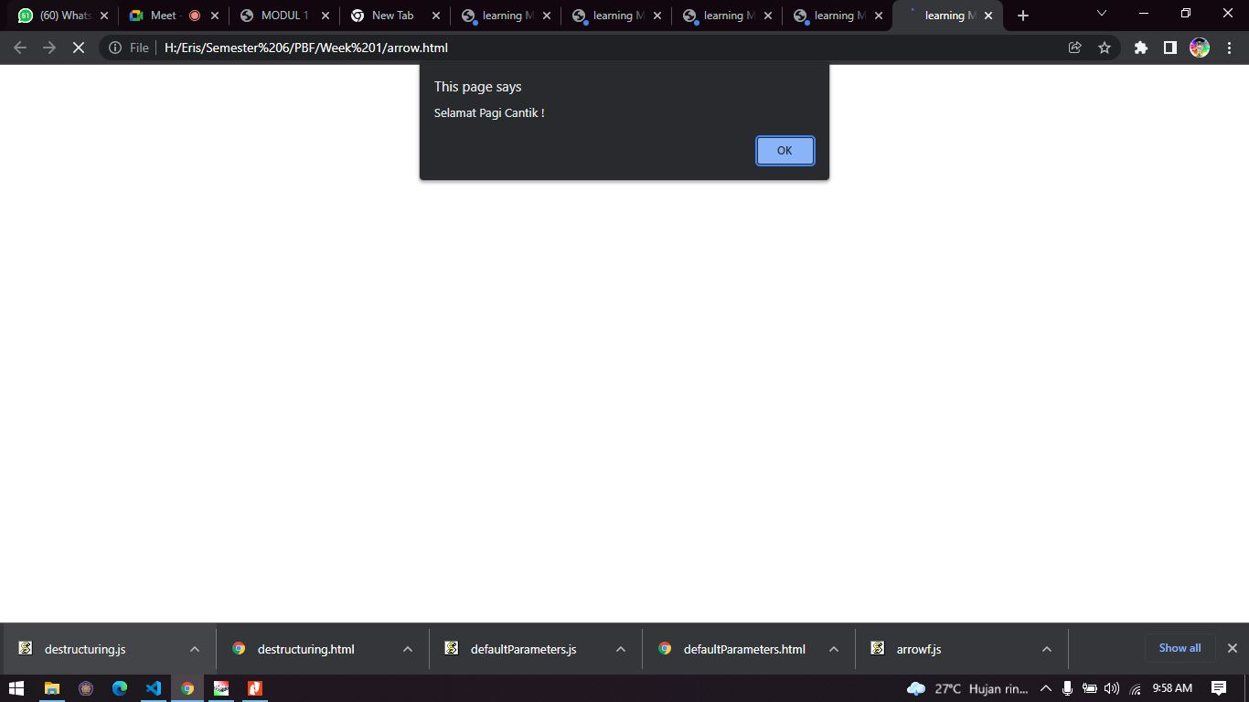

Gambar 15 Hasil

1. **Arrow Function 2**

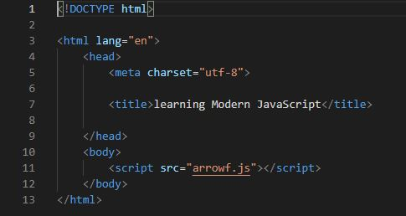

Gambar 16 SC arrowf.html

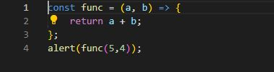

Gambar 17 SC arrowf.js

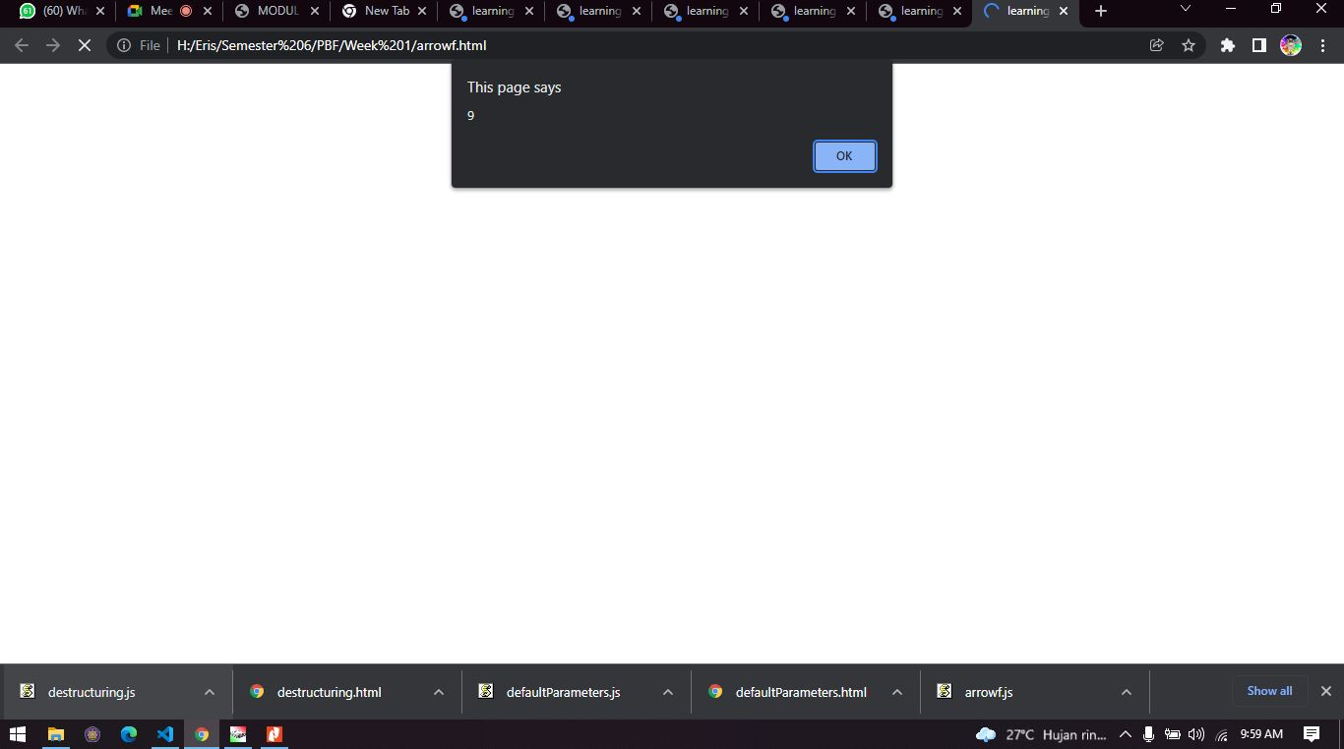

Gambar 18 Hasil

1. **Destructuring Object**

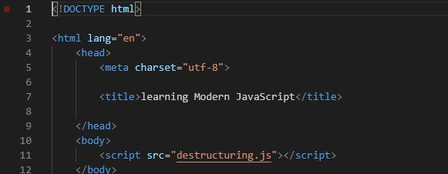

Gambar 19 SC destructuring.html

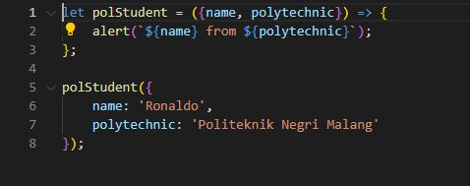

Gambar 20 SC destructuring.js

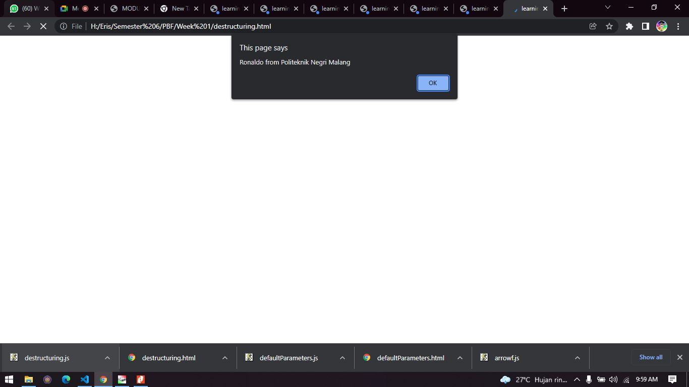

Gambar 21 Hasil

1. **Array**

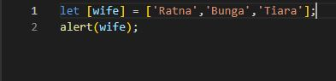

Gambar 22 SC array.js

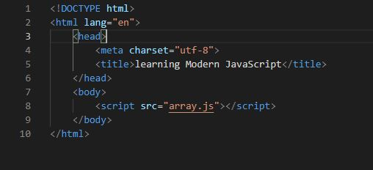

Gambar 23 SC array.html

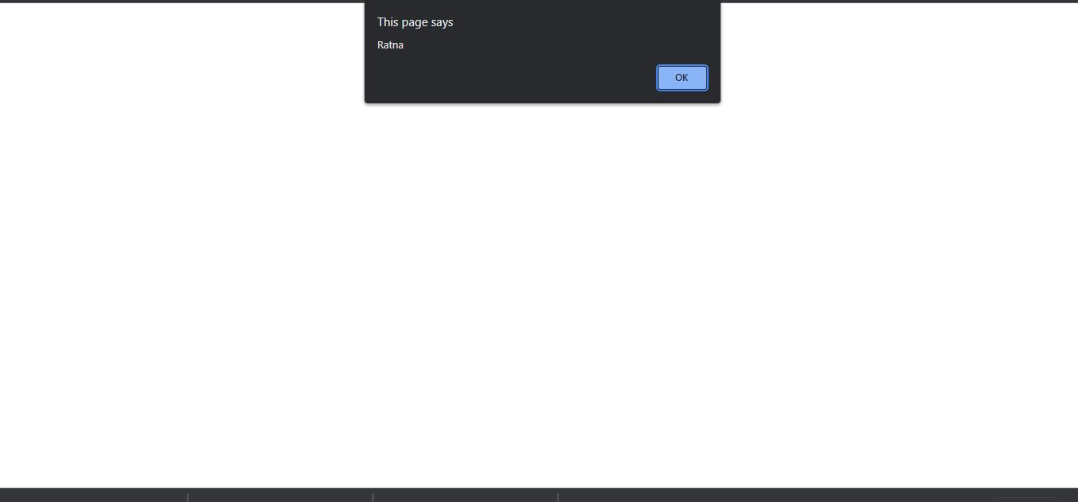

Gambar 24 Hasil 1

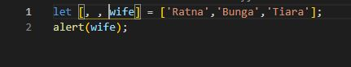

Gambar 25 SC array.js

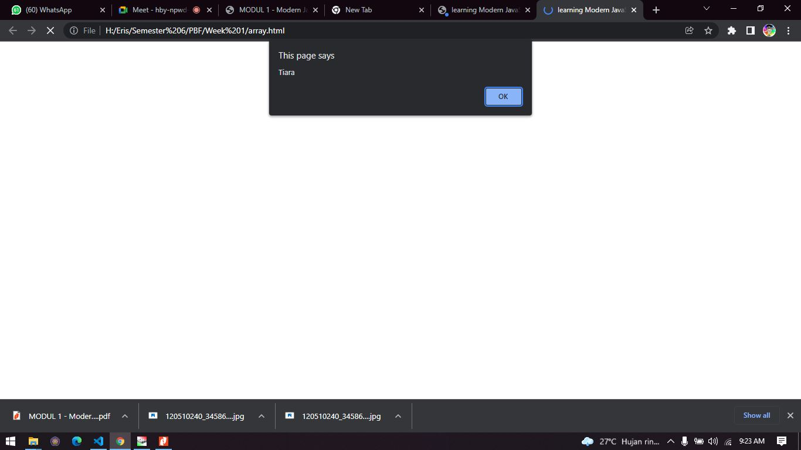

Gambar 26 Hasil 2

1. **Restructuring**

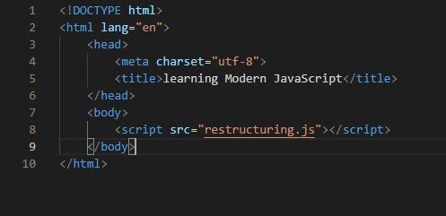

Gambar 27 SC reconstructuring.html

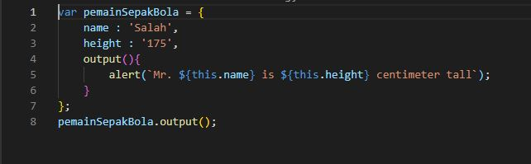

Gambar 28 SC reconstructuring.js

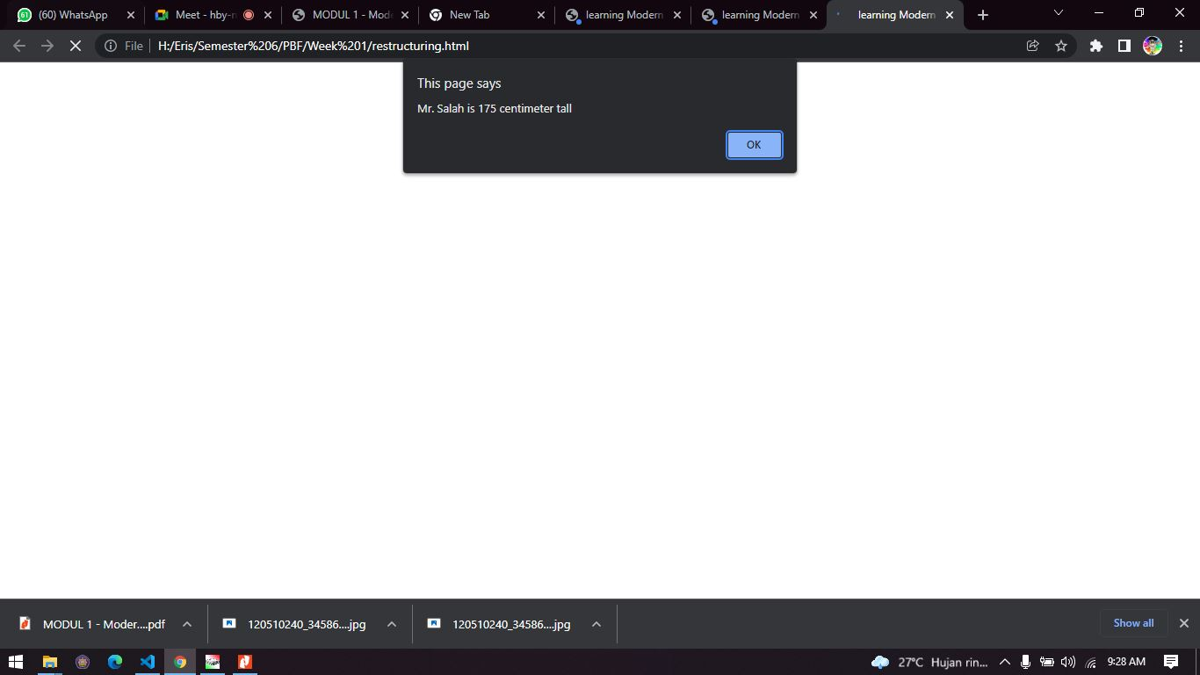

Gambar 29 Hasil

1. **Spread**

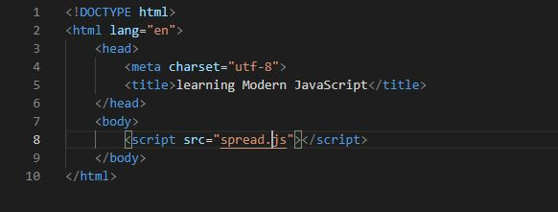

Gambar 30 SC spread.html

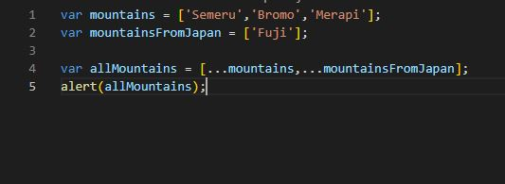

Gambar 31 SC spread.js

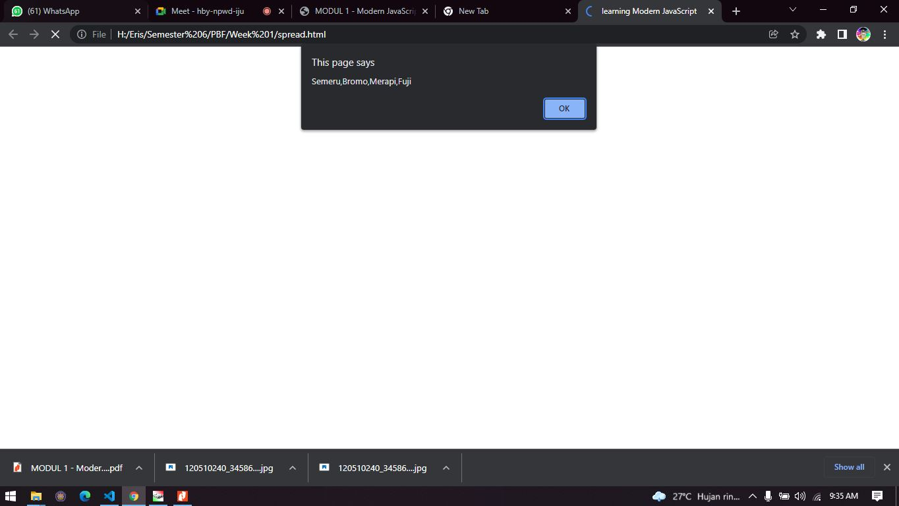

Gambar 32 Hasil

1. **Rest Operator**

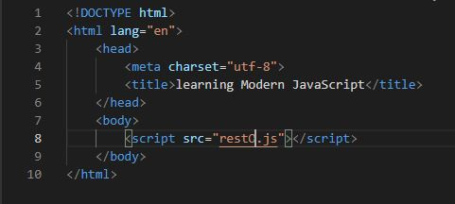

Gambar 33 SC restO.html

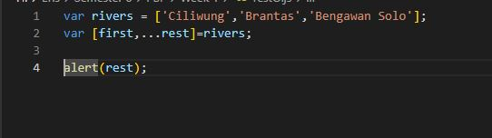

Gambar 34 SC restO.js

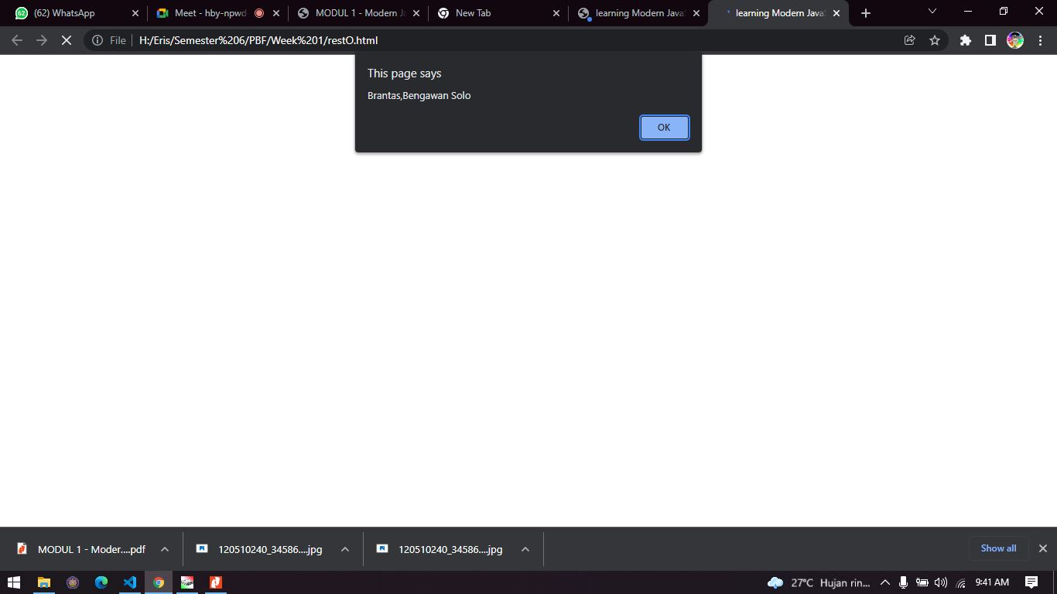

Gambar 35 Hasil

1. **Class Constructor And Super**

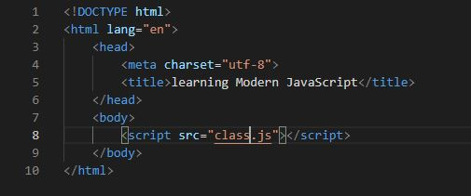

Gambar 36 SC class.html

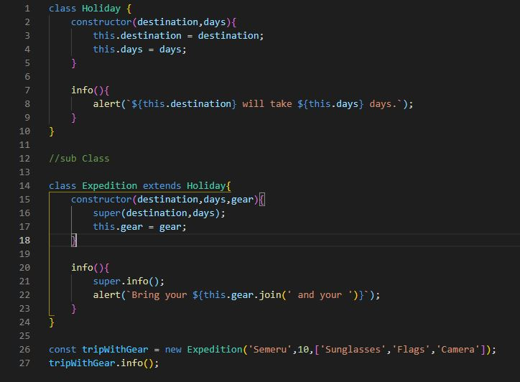

Gambar 37 SC class.js

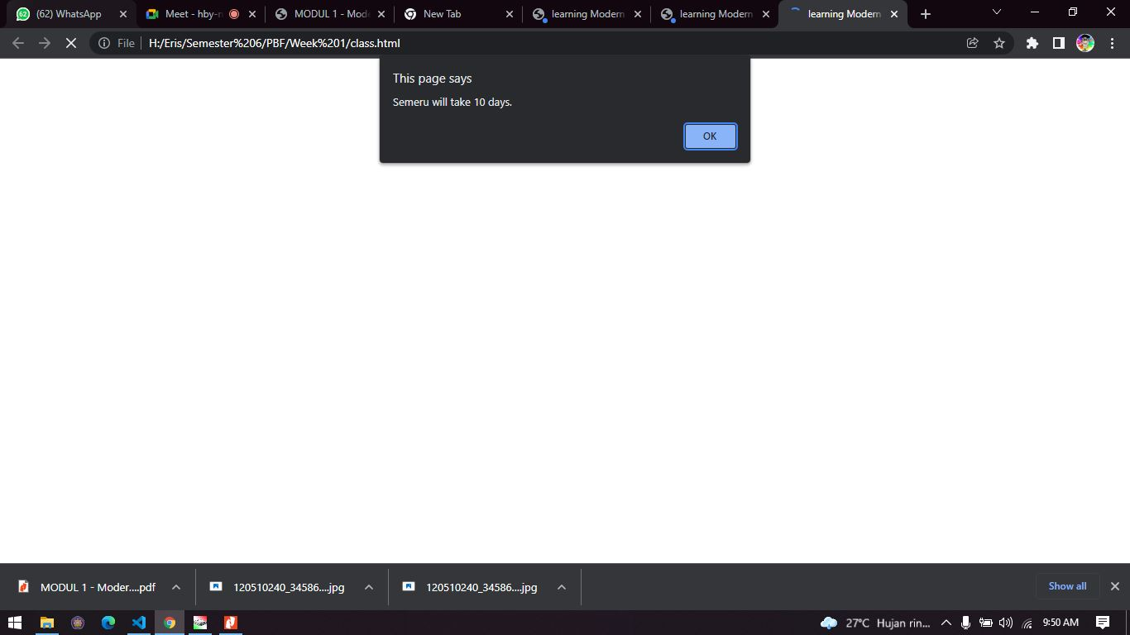

Gambar 38 Hasil 1

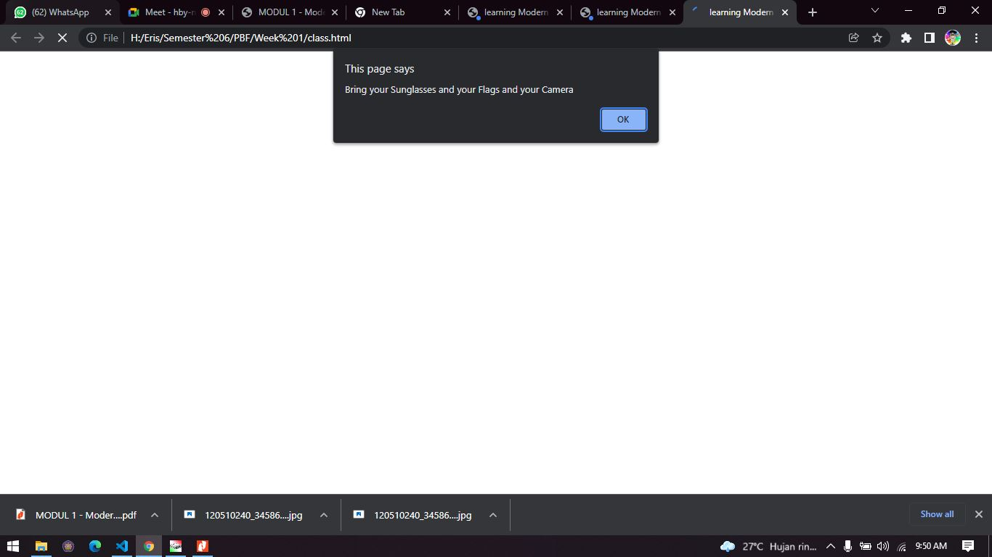

Gambar 39 Hasil 2